Anqi Wang
Engl 250
Ms. McCourt
Feb. 29. 2012
Assignment3
Analyzing the Visual Argument of an Advertisement

In recent decades people are indoctrinated with different kinds of advertisements from media. Among all brands of advertisements, I am impressed with the ad of Nissan LEAF. In this ad, which appeared in Popular Science Magazine in June 2011, Nissan Motors demonstrates that people need environmentally friendly cars to reduce gasoline consumption. As a big revolution among vehicles, Nissan Motors uses color choice, relative pictures and text to recommend the newly designed car called the LEAF and sell the energy-saving concept. LEAF is the first one hundred percent electric family sedan in the world which was marketed in 2011. The target audience should be car and science enthusiasts and environment conservation advocates.

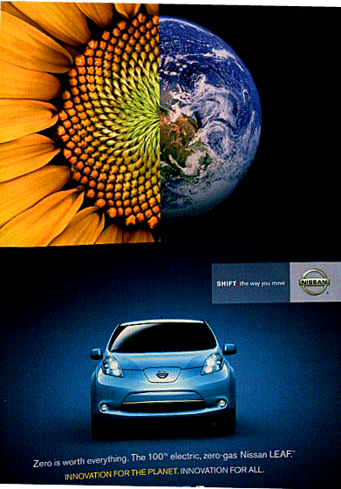
The printed ad of Nissan-LEAF has two parts. The top part is a combination of the Earth and a sunflower. In other words, the left sphere is half of a sunflower and right sphere is half of the Earth. The bottom part is the front view of the car (LEAF) itself with the unique Nissan emblem and slogan on the right side. Below the image of the car, there is a brief introduction for LEAF. Overall, the colors used in this ad are golden yellow, blue, green and black.

One of the visual strategy strengths used in the ad is the choice of color. The top part, the combination of a sunflower and the Earth, the ad uses golden yellow and green to show the exuberant sunflower on the left side. On the right side, it uses sky-blue to show the beautiful earth. Yellow and blue are strong contrasting colors, which can create an interesting visual effect. People will be attracted subconsciously by this contrast of color and hope to read more about the ad. In the bottom portion, the car itself is light blue with charming metallic luster. In comparison, the background color is a gradient effect. This gradient effect is a visual effect where blue color blends gradually into black color from the middle to the edge. All the light gathers to the middle where the Nissan emblem is located. By using gradient, people will easily focus on the lightest part of the image. Furthermore, gradient can give us a feeling of depths. When the viewers see the bottom part of the ad, they feel that a car is driving out from a deep channel. In general, yellow and green colors are the symbol of plants, and blue and white are the symbol of sky and ocean. Both the use of contrasting colors and gradient will bring a dynamic feeling to the image. When people see these natural colors, they feel peaceful, healthy and environmentally friendly. These colors match the purpose of the LEAF: “zero gas, zero emission, and innovation for the planet”.

The second visual strategy is the use of relative pictures. As mentioned above, the top part is a sphere with half of a sunflower on the left and a half of the Earth on the right. The reason for using sunflower is that sunflowers always face the sun. Nissan Motors applies itself to promote solar energy by using this direction. On the official website, it says, “We are working with SunPower industry leader to bring solar power to Nissan LEAF™ owners”. Thus, using a sunflower on the ad is both meaningful and suitable. The planet shows the beauty of our home, the Earth. It is well known that the emission from common vehicles will cause global warming and dust. Dust, like a quilt, covers the sky and makes the air turbid and dirty. However, to show that LEAF is a zero emission car, the creators use an image of a clean and clear planet. Both a sunflower and the Earth show that LEAF is an environmentally friendly car. The bottom part of the ad is the automobile’s appearance. Generally speaking, most of the electric cars are concept cars which are shown in auto shows. However, the front view of the product shows that LEAF is a family sedan rather than a concept car. All of the relative pictures state that this 100% electric car is no longer a concept.

Besides the visual strategies, its verbal strategy is also good. The texts strongly suggest an environmentally friendly car. The verbal for Nissan Motors is “SHIFT_the way you move”. “Shift” has the meaning of change, and “you” means everyone. It may let people think that Nissan Motors always has wonderful new cars to satisfy different customers. At the very bottom of the ad, there are some sentences that refer to LEAF, “Zero is worth everything. The 100% electric, zero-gas Nissan LEAF.” Actually the full version from Nissan official website has additional words “zero emission, no tailpipe”. “Zero is worth everything” means that we should try our best to reduce the gasoline consumption and exhaust less harmful gas. The advent of LEAF is a big revolution in automotive industry. It is a 100% electric car, which is completely and environmentally friendly. Zero emission will attempt to slow global warming and reduce acid rain, which are the two biggest environmental issues in the world. That is why they say LEAF is an “innovation for the planet and all”.

In general, Nissan LEAF has a high-level and creative ad, because of its use of colors, pictures and a brilliant slogan. It is an effective ad, not only to represent its environmental concern and energy-saving concept, but also to attract car and science enthusiasts and environment conservation advocates as their customer groups.

